**Lab Assignment 2**

**Team : 1**

Charan Kothapalli - 15

Sai Srinivas Vidiyala - 27

Greg brown -

Sai Sri - 18

Priyanka -7

**Introduction** :

We are Generating Captions (Show & tell ) for Images on Dataset using various technique and evaluating performance

**Explanation**: Given my images for key words dog ,Tree,Field,grass show and tell given the captions for the given images

We converted into json format and given input for caption metrics master and got results in BLEU, CIDER, METEOR and ROGUE measures

GitHub Link: <https://github.com/vidiyalasaisrinivas/CS5542_BigdataApplications/tree/master/Lab2>

Dataset :COCOQA

Generated captions for your own dataset using the Show and Tell

Given path for images and reading

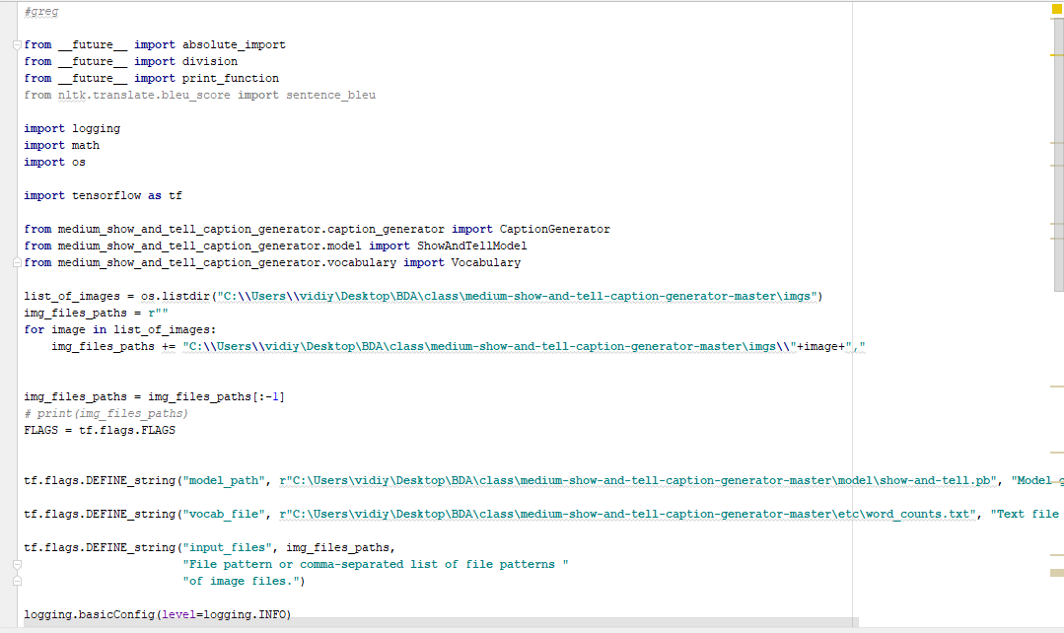

Generating Captions

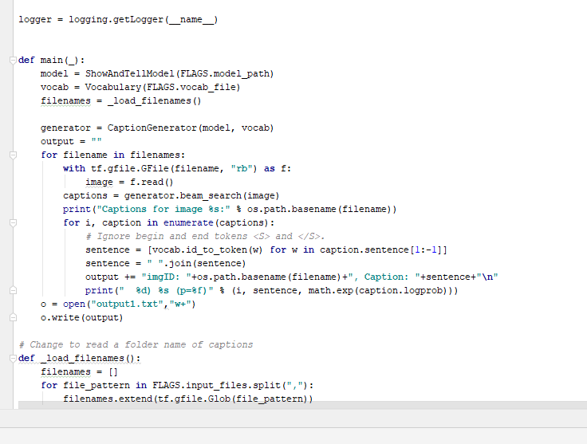

Got 4 Captions for each image

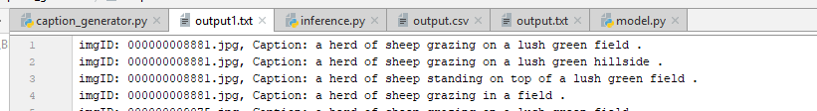

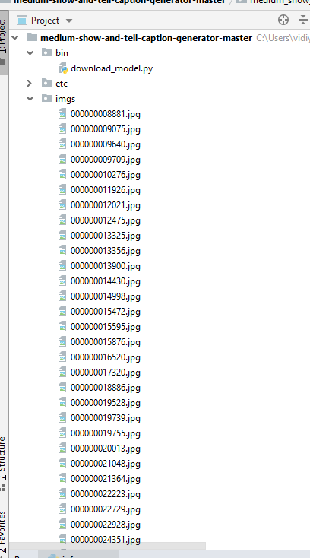

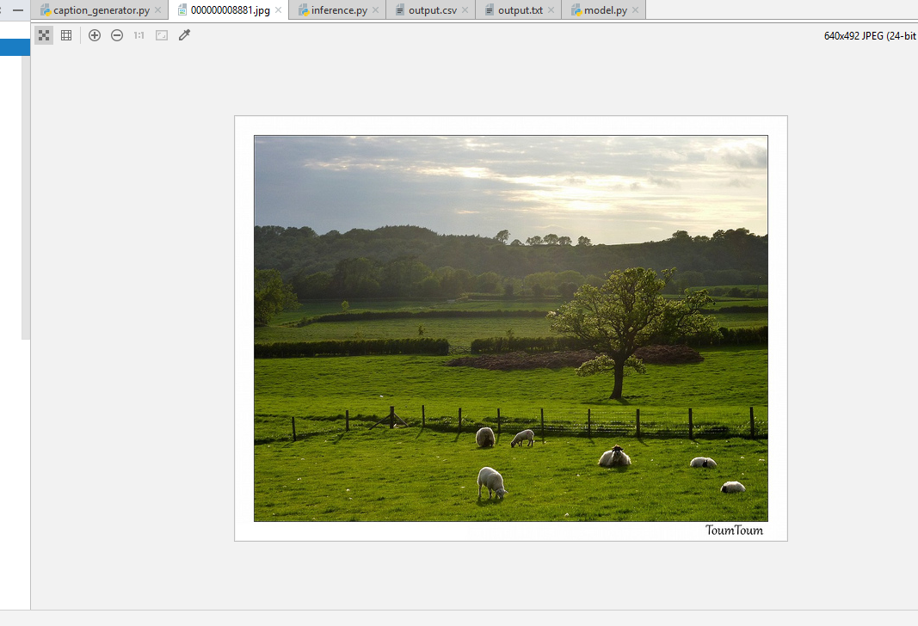

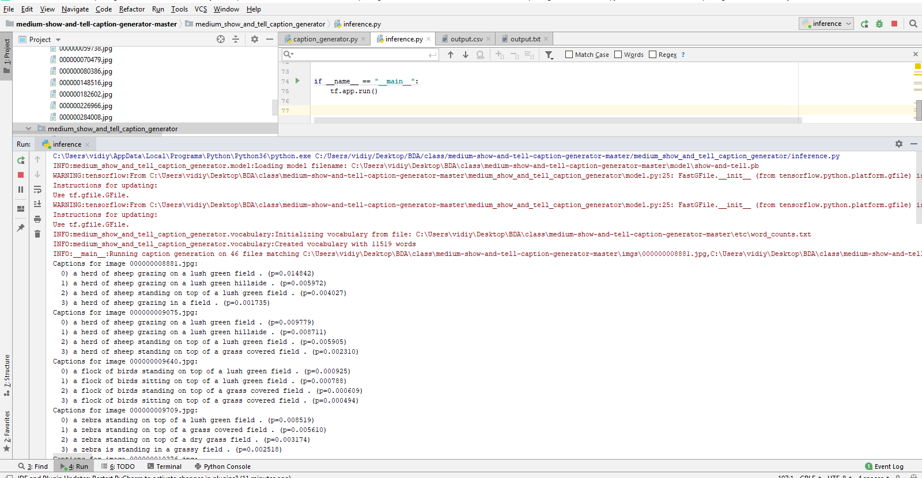

Model and Generated 4 captions for each image. (Beam Search k=4)

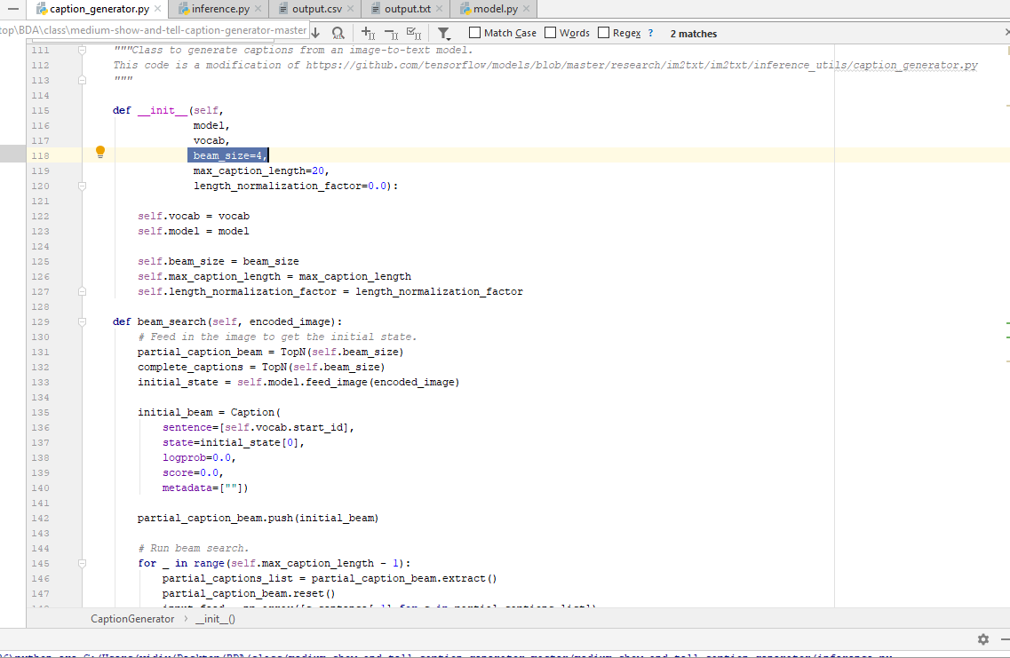

Saved output

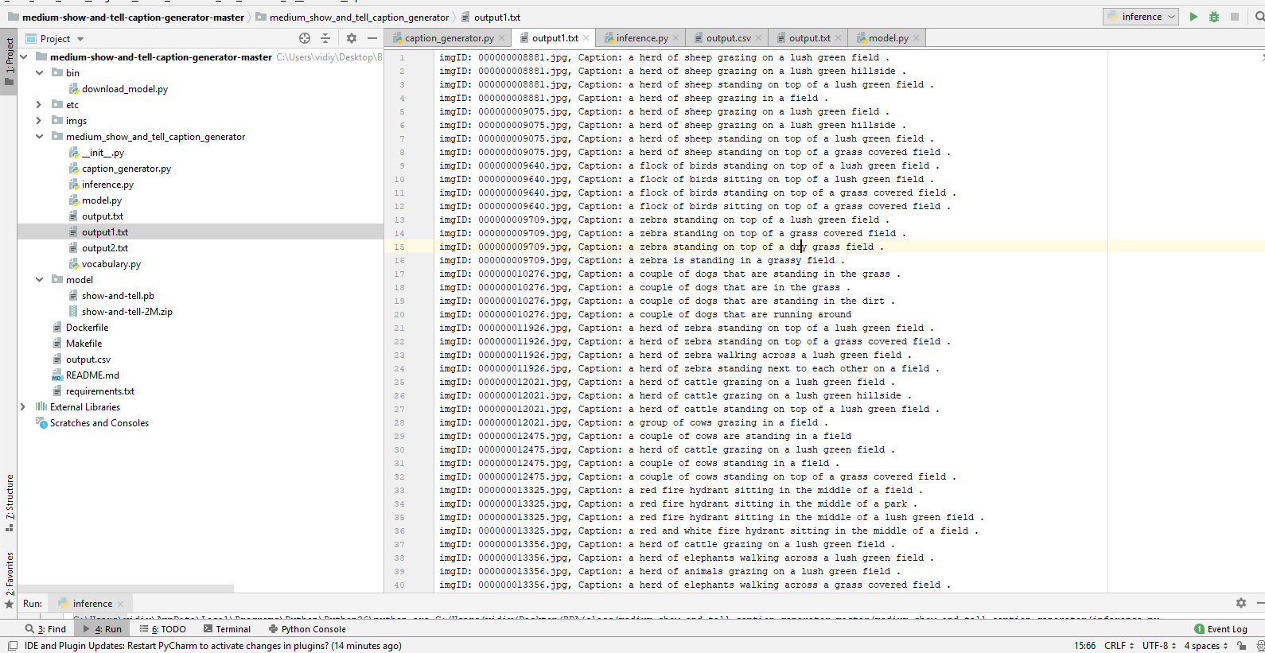

accuracy in BLEU, CIDER, METEOR and ROGUE measures.

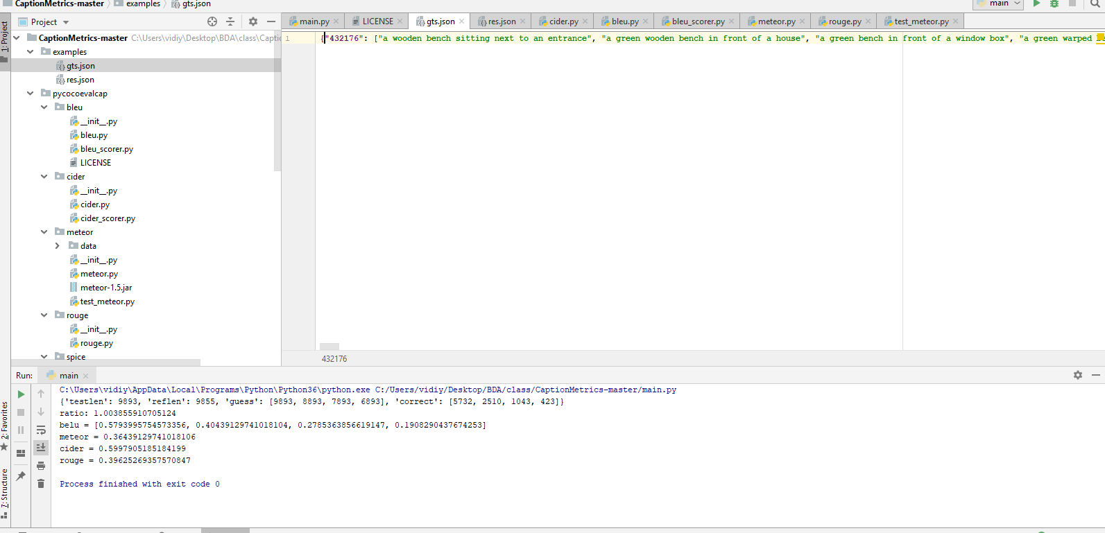

Taken the converted input of caption in json format

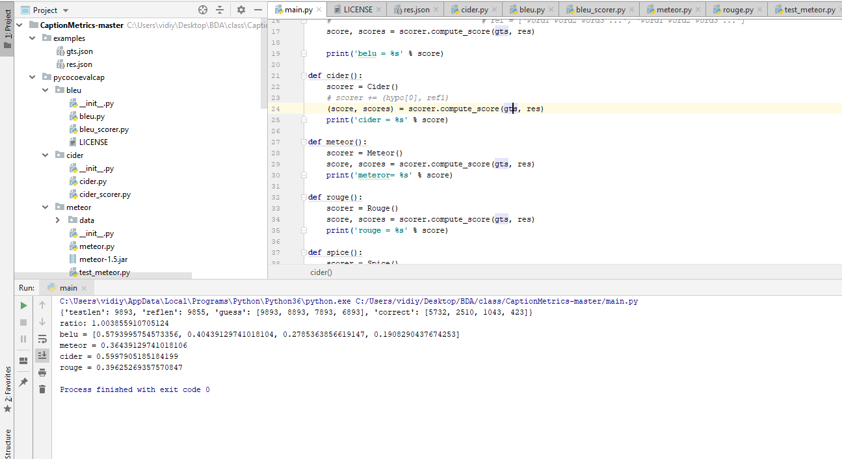

Output

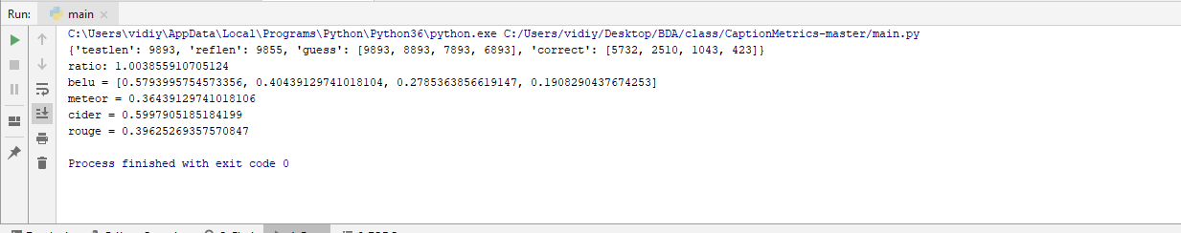

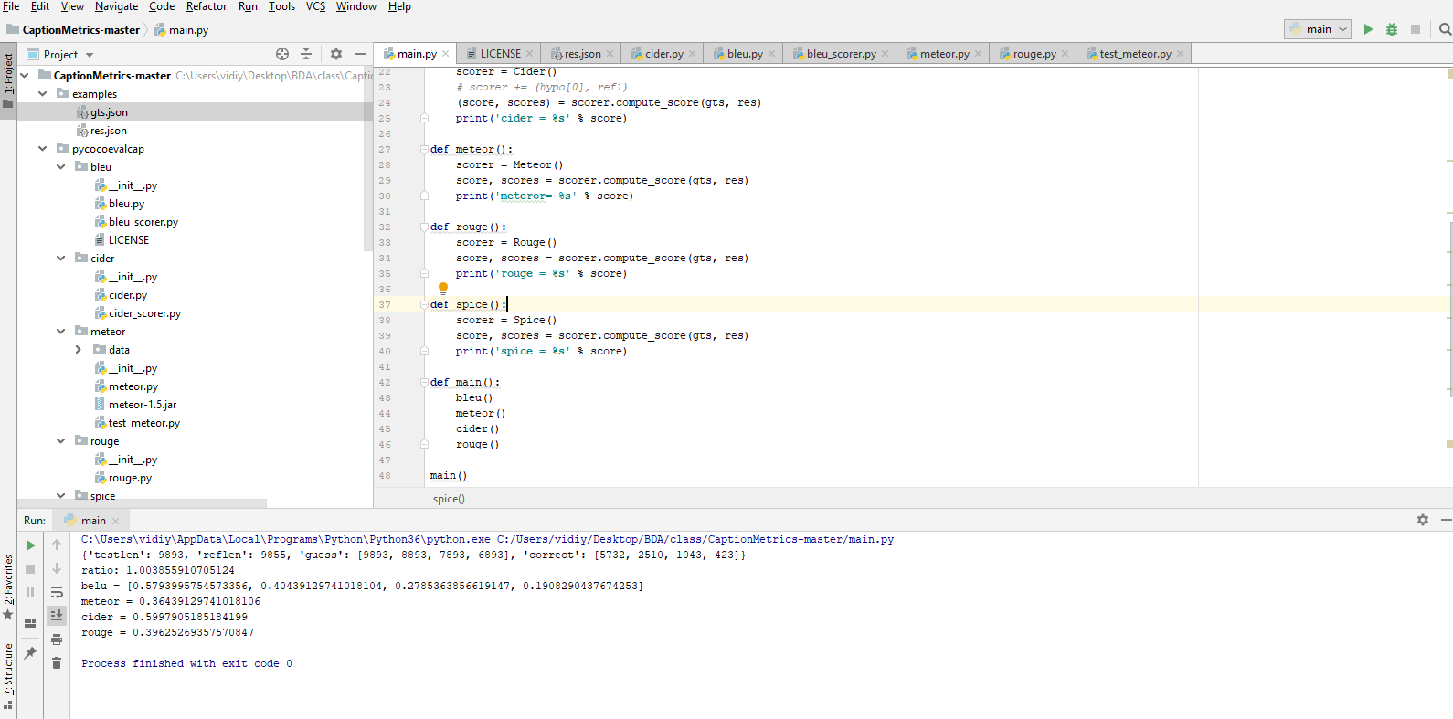

Run the main method got the results

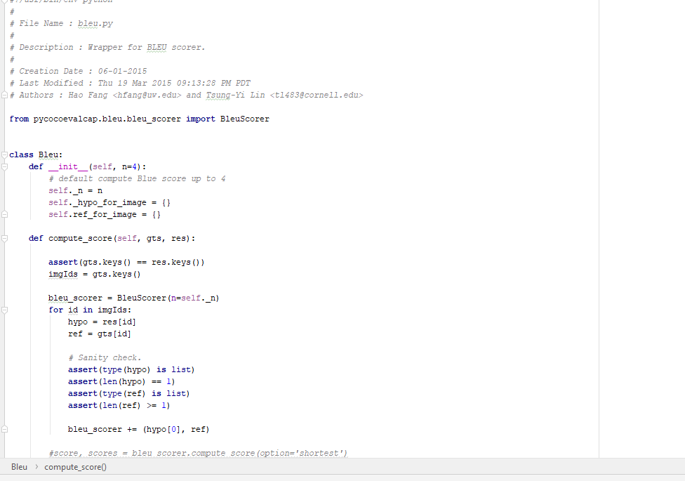

Blue functionality

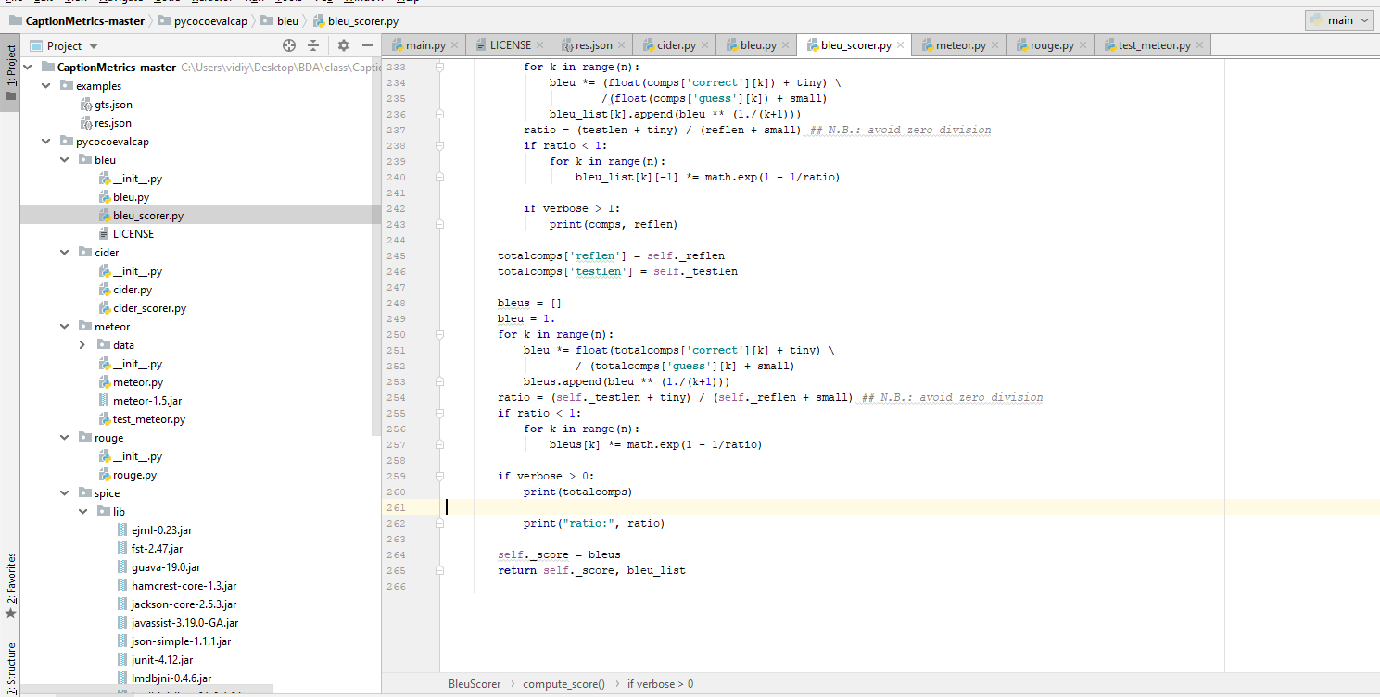

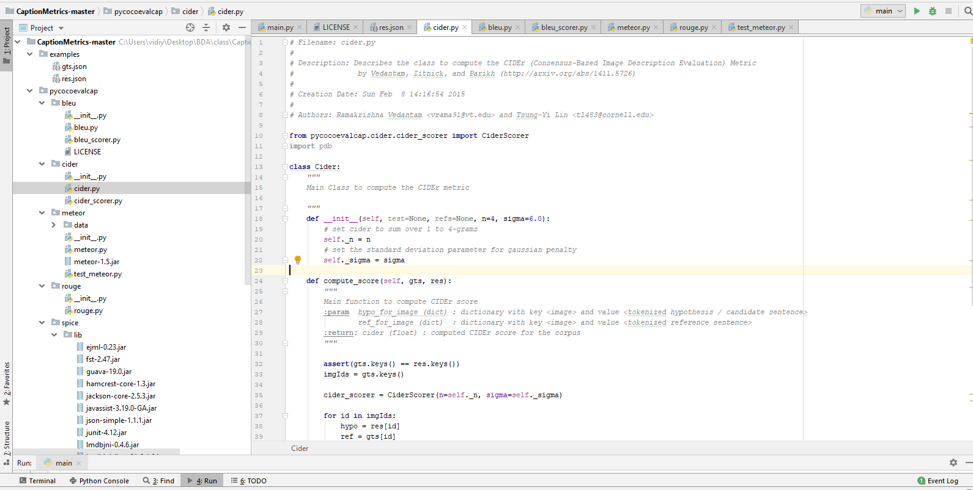

Cider Functionality

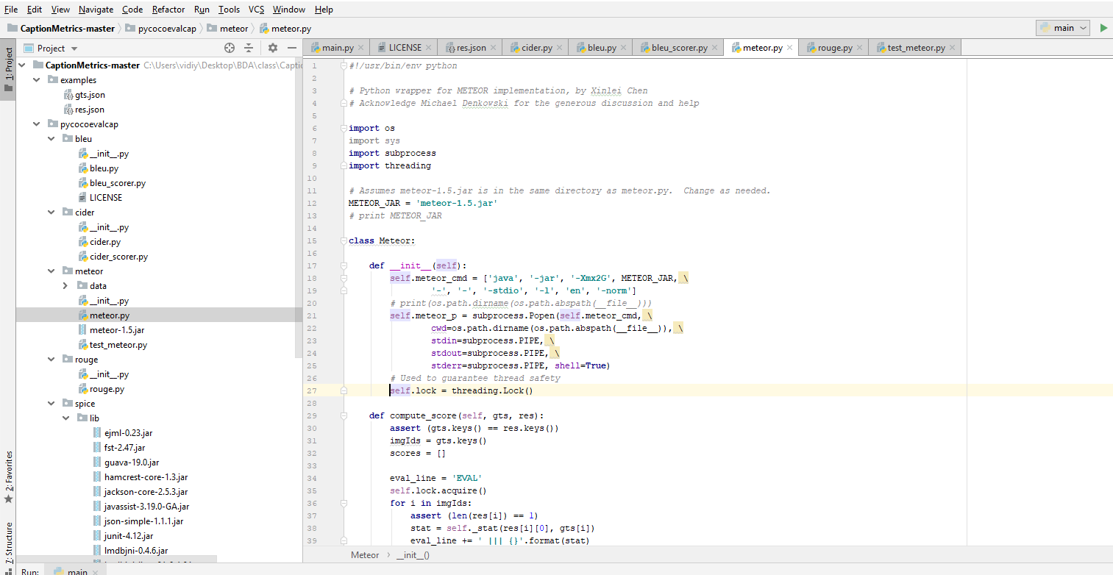

Metero functionality

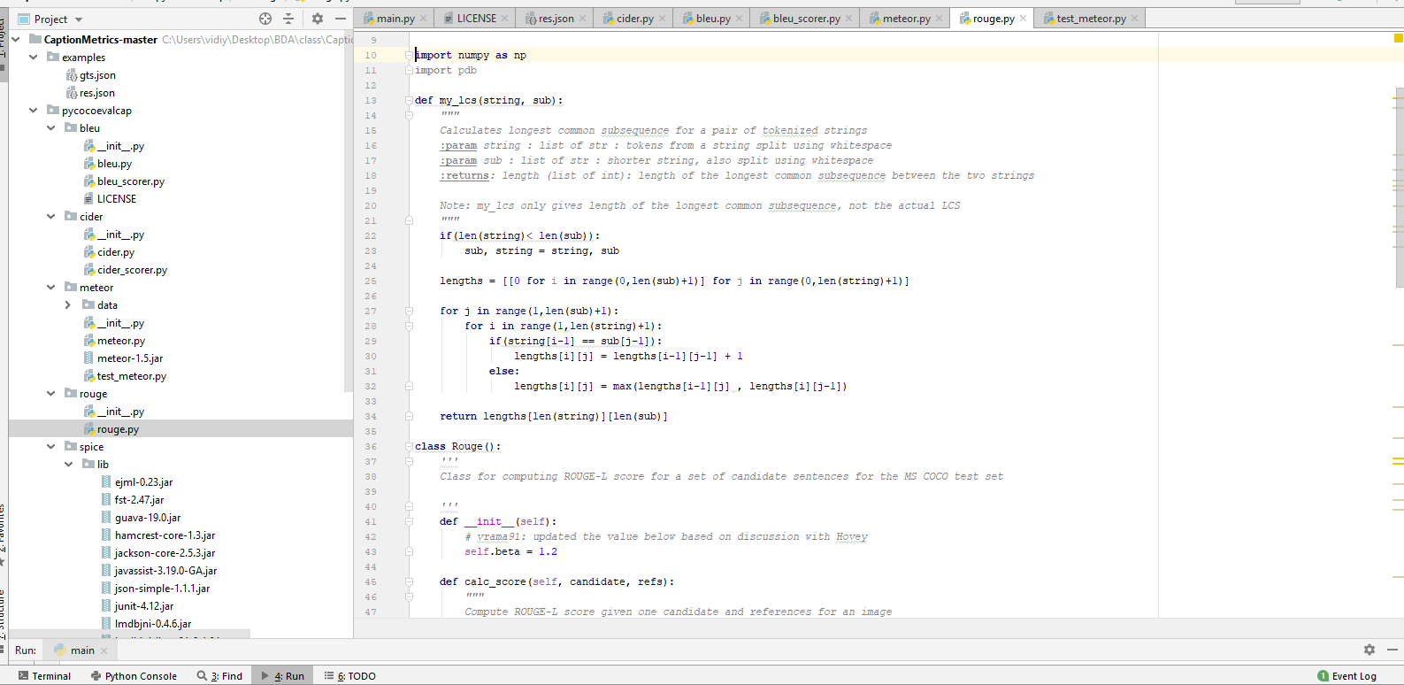

Rouge.py